**Grove - Encoder**

窗体顶端

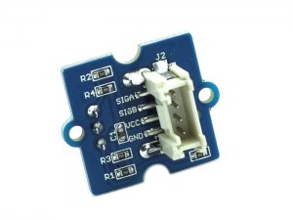

http://www.seeedstudio.com/depot/includes/templates/pure_green/images/next_l.gif

* [http://www.seeedstudio.com/depot/bmz_cache/b/bff16a3d4b29890ac7c01982ca700778.image.55x41.jpg](http://www.seeedstudio.com/depot/images/product/Grove%20Encoder.jpg)
* [http://www.seeedstudio.com/depot/bmz_cache/3/39562762b18653d063cd1f125bda8a71.image.55x41.jpg](http://www.seeedstudio.com/depot/images/product/Grove%20Encoder_01.jpg)
* [http://www.seeedstudio.com/depot/bmz_cache/7/713a09d83ea307c8f329562584c1e04a.image.55x41.jpg](http://www.seeedstudio.com/depot/images/product/Grove%20Encoder_02.jpg)

http://www.seeedstudio.com/depot/includes/templates/pure_green/images/next_r.gif

* **Price:**

$4.90  [(Price Feedback)](javascript:void())

* **SKU:**

COM01112P

* **Weight:**

8Gram

* **Units in Stock**

64

* **Designed by:**

[Seeed Studio](http://www.seeedstudio.com/)



[Other products from designer](http://www.seeedstudio.com/depot/seeed-studio-m-23.html)

* **Quantity:** Max: 64  
  
* [Add to Wish List](http://www.seeedstudio.com/depot/index.php?main_page=un_wishlist&products_id=1352&action=un_add_wishlist)

Description



窗体底端